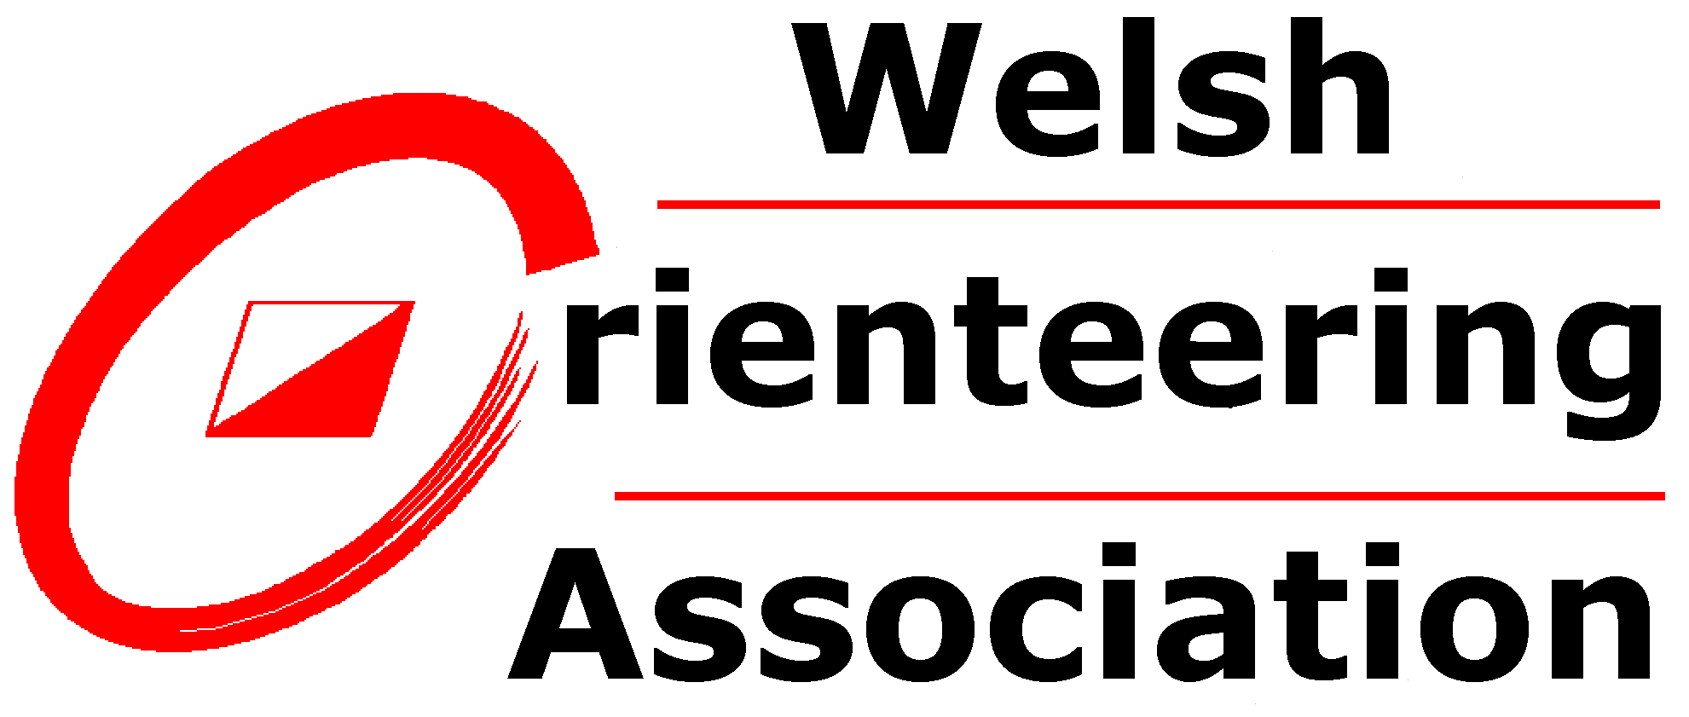

Welsh Orienteering Association Safeguarding Officer role description

Introduction

The Welsh Orienteering Association (WOA) is fully committed to safeguarding the welfare of all children and vulnerable adults in its care. We recognise the responsibility to promote safe practice and to protect children and vulnerable adults from harm, abuse and exploitation. To demonstrate this the role of WOA Safeguarding Officer is a full committee role with all the rights and responsibilities this brings.

The WOA Safeguarding Officer will:
1. Act as the lead safeguarding person for WOA and the link between WOA and Welsh Orienteering clubs to regularly review any protection issues that arise.
2. Promote and implement appropriate procedures to safeguard the well-being of children and vulnerable adults and protect them from abuse. Develop and maintain a child and vulnerable adult protection policy to complement British Orienteering’s “O-Safe” guidelines and promote awareness of this amongst WOA members.
3. Liaise with WOA Coaching Officer to maintain a register of all coaches and coaching assistants who are working with children and vulnerable adults and ensure they have an appropriate and current Disclosing & Barring Service checks.
4. Support all adult WOA members and volunteers to obtain appropriate child protection and protection of vulnerable adult training by identifying training sources.
5. Respond to any allegations of misconduct or abuse of children or vulnerable adults or breach of a WOA Code of Conduct (once it has been developed) as well as implementing, where appropriate, the relevant disciplinary and appeals procedures (once developed).
6. Act as the link between WOA and Sports Wales with regard to child and vulnerable adult protection.
8. The WOA Safeguarding Officer must have up-to-date training in child and vulnerable adult protection.
9. Attend all WOA general, annual and extraordinary meetings and provide a report. Provide a written report to be part of the WOA Annual Report.

